# MYSQL Practical 1

1. Open your browser at the following URL <http://mysql05.comp.dkit.ie/phpmyadmin/>
2. 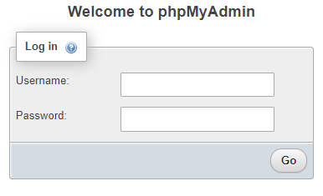Use you student number and the password supplied in the ‘root’ email, to log into your mysql account
3. When successfully logged in, the phpMyAdmin interface below should be displayed

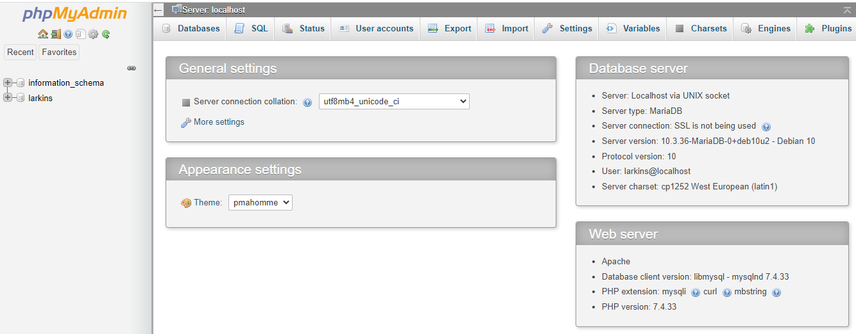

1. A default database with your student number is already created
2. Open the database by clicking on your student number in the left hand panel

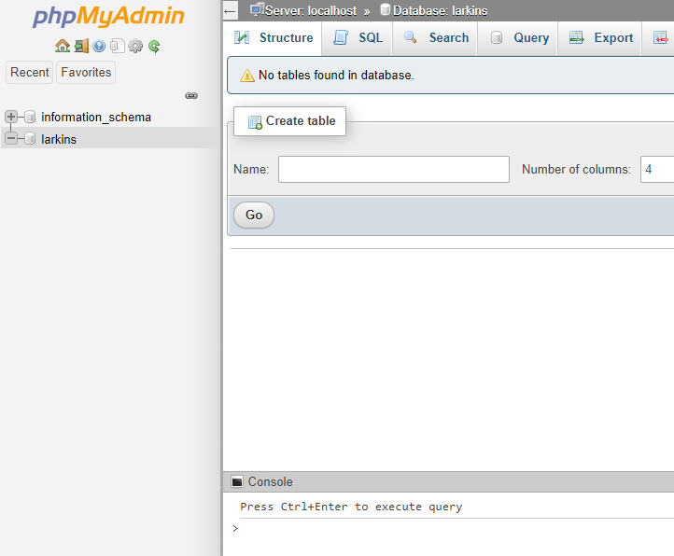

1. 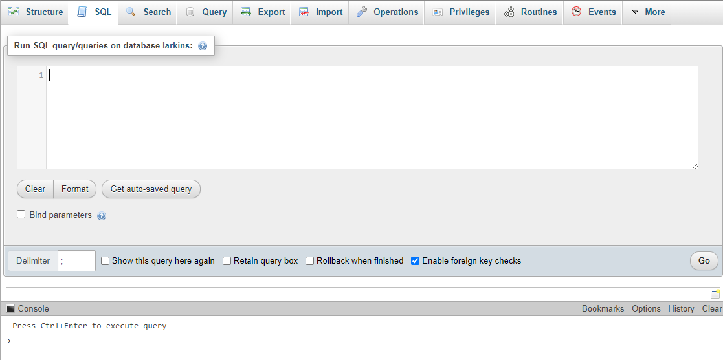Click on the SQL tab to open the editor

In the SQL Editor you can enter SQL commands to create tables and insert data into those tables etc.

**SQL Commands:**

**create table …**

**insert into …**

**Database Tables**

Try the following commands:

**Use Notepad++ to create the commands in an SQL file**

**Copy the commands to the SQL editor in phpMyAdmin**

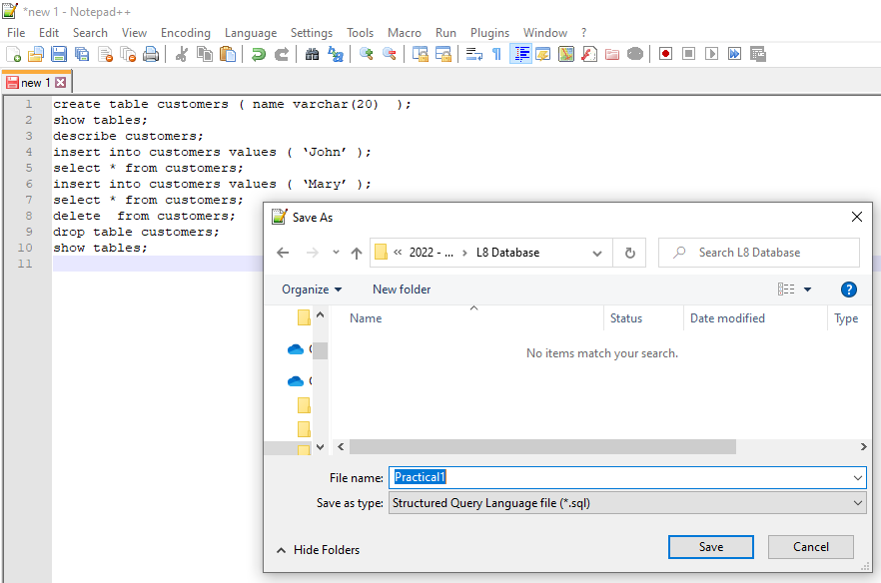

**create table customers ( name varchar(20) );**

* creates a very simple table with one column of type varchar.
* You can look up data types on the MySql documentation website

**show tables;** - shows the tables in the database

**describe customers;** - gives details about the customers table structure

**insert into customers values ( ‘John’ );** - adds a row to the table

**select * from customers;** - show ALL (*) the rows of data

**insert into customers values ( ‘Mary’ );** - adds a row to the table

**select * from customers;** - show ALL (*) the rows of data

**delete from customers;** - deletes ALL rows from table (be careful!)

**drop table customers;** - deletes the whole table

**show tables;** - the customers table should no longer be present

**Exercise:**

Recreate the customer table with three fields:

**create table customers ( firstname VARCHAR(20), surname VARCHAR(20), address VARCHAR(20));**

Populate it with the records from the flat file database notes

**insert into customers values(‘Joe’, ‘Murphy’, ‘Dundalk’);**

**insert into customers values(‘Ann’, ‘Glynn’, ‘Ardee’);**

etc……

Try the following commands:

**select * from customers;** - show ALL (*) the rows of data

**select firstname, surname from customers;** - show firstname and surname for all rows of data

**select address from customers;** - show address for all rows of data

**select distinct address from customers;** - show only distinct addresses for all rows of data

To return results that match a criteria use the **where** clause with the select statement

Try the following commands:

**select * from customers where firstname = ‘Joe’;**

**select firstname, surname from customers where address = ‘Dundalk’;**

AND Operator

**select * from customers where firstname = ‘Vera’ and surname = ‘Nolan’;**

OR Operator

**select * from customers where firstname = ‘Joe’ or firstname = ‘Ann’;**

Wildcards

**select firstname, surname from customers where address like ‘D%’;**

**select firstname, surname, address from customers where firstname like ‘A%’ or address like ‘%o%’;**

Extra Work

Try commands to do the following

All details for customers who live in Ardee

All details for customers with first name Harry or surname White

First name and Surname for customers who live in Blackrock

First name and Surname for customers with an address that begins with D

All details for customers with surname that begins with G and live in Ardee

Address for Tim Woolworth